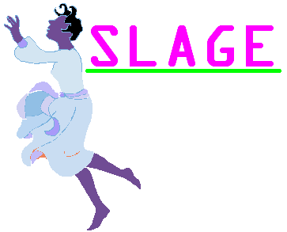
11-Oct-2011

RE: JUBA WOMEN EDUCATION SCHEME
SLAGE is a South Sudanese non-profit making organization based in Juba- Tong-Ping (Tong-Ping market opposite ARC) that has the main aim of empowering women in the society. We want to empower women in terms of knowledge, socially and economically.
We are therefore starting a women education scheme for all South Sudanese women aged above 16 years living in Juba and would like to study, to come and register at our office. This scheme is for those who have dropped out of school and would like to resume (at either Primary or Secondary level).
Registration starts on Monday 17th-Oct-2011 and ends on 15th-Nov-2011.
We look forward towards large crowds.
For Projects manager
Mob: 0955230948

